**Institute of Space Technology**

**DBS Project Report**

**Car Maintenance System**

**Instructor**

Mam Madiha

**Submitted By**

Malik Hamza Khalid

200901060

Abdullah Ahmad

200901057

**BS CS 01 – B**

**Department of Computer Science,**

IST, Islamabad.

[29th June 2022]

## Table of Content

|  |  |
| --- | --- |
| **Content** | **Page#** |
| Project Title | 3 |
| Abstract | 3 |
| Introduction | 4 |
| Objective | 4 |
| Project Description | 4 |
| Project Breakdown | 5 |
| Methodology | 5 |
| Conclusion | 6 |

**Project Title:** ‘Car Maintenance Database System’

## Abstract:

Today we are living in an advance era surrounded with technology. So, every system needs a database in which we can store its data and we can retrieve it easily. So, we came up with a idea to create a database system for our car maintenance workshop so that the data of the customers, cars and bill can be maintained.

Thus, we applied the knowledge of Database System that we gained in the class and using our previous experience with sql we developed a Database System that cover up such a problem in a Car Maintenance System.

## Introduction:

This project is designed to manage the database of Car Maintenance Workshop. The records of Customers, Employees, services provided (Replacement of parts, Maintenance ) and billing etc are being stored in the database. We can perform all basic three function on these record Addition, Deletion, Updating. We can also individually search for the record of anything from the database easily. The agent can easily maintain the record of everything easily and can also retrieve them for them database. We also provide graphic user interface so that the user can easily use the Application.

## Objective

1. The main objective of our Maintenance system is to maintain the records of Owner, Customers, Cars , or services provided and parts replaced.
2. It helped the user to maintain the records of all entities easily.
3. It helps the user to get the record faster for their client without any delay.
4. This system increases the efficiency in a car maintenance workshop and better management of the workshop.
5. Adding a new record and fetching the old record in the records is easy.
6. This system completely automates all your workshop activities.

**Project Description**

The backend was created by using SQL Server as IDE and SQL as the programming language. For our frontend, we use C#. In which we created an interactive interface for the user. We connect our local host database with C# and Sql we are performing queries on the database.

We have main Entities in which we are storing our Data. We can perform **Addition**, **Deletion**, **Updating**, **Searching** on these 6 Entities while the 7th Entity Usertable only store the username and password data of the admin required for the login.

**Project Distribution:**

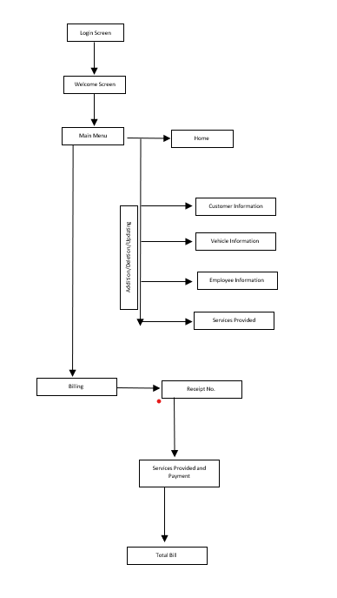

**Output:**

